Andy Cherney

10/23/2023

Week4Meet - 10 pts

Turn in on BBL as soon as complete, but before end of day Sunday following the lecture.

===============================

Read both programs.

import java.util.Scanner;  
import java.util.ArrayList;  
import java.util.Random;  
  
/************************************  
 * TestPrep.java  
 * Runs a little game involving caffeine  
 * @author Tammy Pirmann  
 * @version 20210414  
 ********************************/  
public class TestPrep {  
 public static void main(String args[]){  
 Scanner keyboard = new Scanner(System.in);  
 Random randGen = new Random();   
 ArrayList<Cafe> drinks = new ArrayList<Cafe>();   
   
 System.out.println("It's time to get ready for midterms!");  
 System.out.println("You know you have to be alert for study sessions.");  
 System.out.println("Caffeinated beverages from your favorite cafe will work.");  
 System.out.println("We all like different drinks, so get ready to enter yours.");  
 System.out.println("You will need the name, the mg of caffeine and the price.");  
 System.out.println("When you are done, enter DONE then 0 then 0.");  
   
 String name = "na";  
 int caffeine;  
 double price;  
   
 while (!name.equalsIgnoreCase("DONE")){  
 System.out.println("Enter a drink name or DONE: ");  
 name = keyboard.nextLine();  
 System.out.println("Enter the caffeine in mg: ");  
 caffeine = keyboard.nextInt();  
 System.out.println("Enter the price: ");  
 price = keyboard.nextDouble();  
 keyboard.nextLine();  
 if (!name.equalsIgnoreCase("DONE")) {  
 drinks.add(new Cafe(name, caffeine, price));  
 }  
 }  
  
 int max = drinks.size();  
 System.out.println(max);  
   
 System.out.println("The human body can handle about 500 mg of caffeine before bad things start to happen.");  
 System.out.println("You will now play chicken with your drink choices. Try to stay alert without going over.");  
 System.out.println("You can DRINK or be DONE");  
 System.out.println("The drink will be chosen at random from the ones you entered");  
   
 int totalCaffeine = 0;  
 String tally = "";  
 String choice = "DRINK";  
 while (!choice.equalsIgnoreCase("DONE")){  
 System.out.println("You can DRINK or be DONE!");  
 choice = keyboard.nextLine();  
 Cafe bev = drinks.get(randGen.nextInt(max));  
 totalCaffeine += bev.getCaffeine();  
 tally += "["+bev.toString() +"] ";  
 }  
  
 if (totalCaffeine > 500){  
 System.out.println("You lose! You get the jitters and can't remember anything you studied today!");  
 }   
 else if (totalCaffeine > 100){  
 System.out.println("You win! You stay alert for the whole study session!");  
 }   
 else{  
 System.out.println("What's this? It's like you didn't play! You fell asleep on your book.");  
 }  
 System.out.println("You drank: " + tally);  
   
 }  
}

1. The program will prompt the user to enter drinks and will continue to do so until the user enters DONE
   1. Inputs:
      1. Drink name
      2. Caffeine amount
      3. Price
   2. If the user did not enter done, the program will add the drink object to the arraylist drinks
2. The game will choose the drinks at random and then the user has to either drink or be done
3. The objective is to drink enough caffeine without going over
   1. As long as the choice is not done, the user will continue to choose to drink or be done
   2. If the user drank more than 500, they lose
   3. Between 100 and 500, they win
   4. Otherwise, the user fell asleep

/************************  
 * Cafe.java  
 * Class definition of a caffeinated drink  
 * @author Tammy Pirmann  
 * @version 20210414  
 **************************/  
public class Cafe {  
  
private String name;  
private int caffeine;  
private double price;  
  
public Cafe(){  
 name = "Coffee";  
 caffeine = 100;  
 price = 1.50;  
}  
public Cafe(String n, int c, double p){  
 name = n;  
 caffeine = c;  
 price = p;  
}  
  
public String getName(){  
 return name;  
}  
public int getCaffeine(){  
 return caffeine;  
}  
public double getPrice(){  
 return price;  
}  
public String toString(){  
 return (name + ", " + caffeine + "mg of caffeine at $" + price);  
}  
}

Label these programs with descriptions of what each line or segment is doing. A segment may be several lines of code or part of one line of code.

Be sure to highlight where the two programs interact with each other.

This program defines the Cafe object. Its constructor can either be with parameters or without parameters with defaults being coffee for the name of the drink, 100 for the caffeine amount, and 1.50 for the price. It has getter methods for each of these attributes and a toString method, which returns all the attributes together.

See the files for all comments

Everything below this line relates ONLY to the problem discussed in class, the code we wrote together.

I understand the problem introduced in class to be: (in your own words)

We need to modify the program to show the player what they drank and their current total of caffeine before they decide, drink or done

My UML Diagram for these classes: (feel free to paste in a photo of a hand done diagram)

**Cafe**

Name : String

Caffeine: int

Price: double

Getters:

getName()->String

getCaffeine()->int

getPrice()->double

Methods:

toString()->String

The solution to the problem were the following programs: (provide the names of the .java files only)

Cafe.java

TestPrep.java

I tested the solution with at least 3 different value sets. The test data and results are:

(use this format: var1 = data, var2 = data, etc -> result)

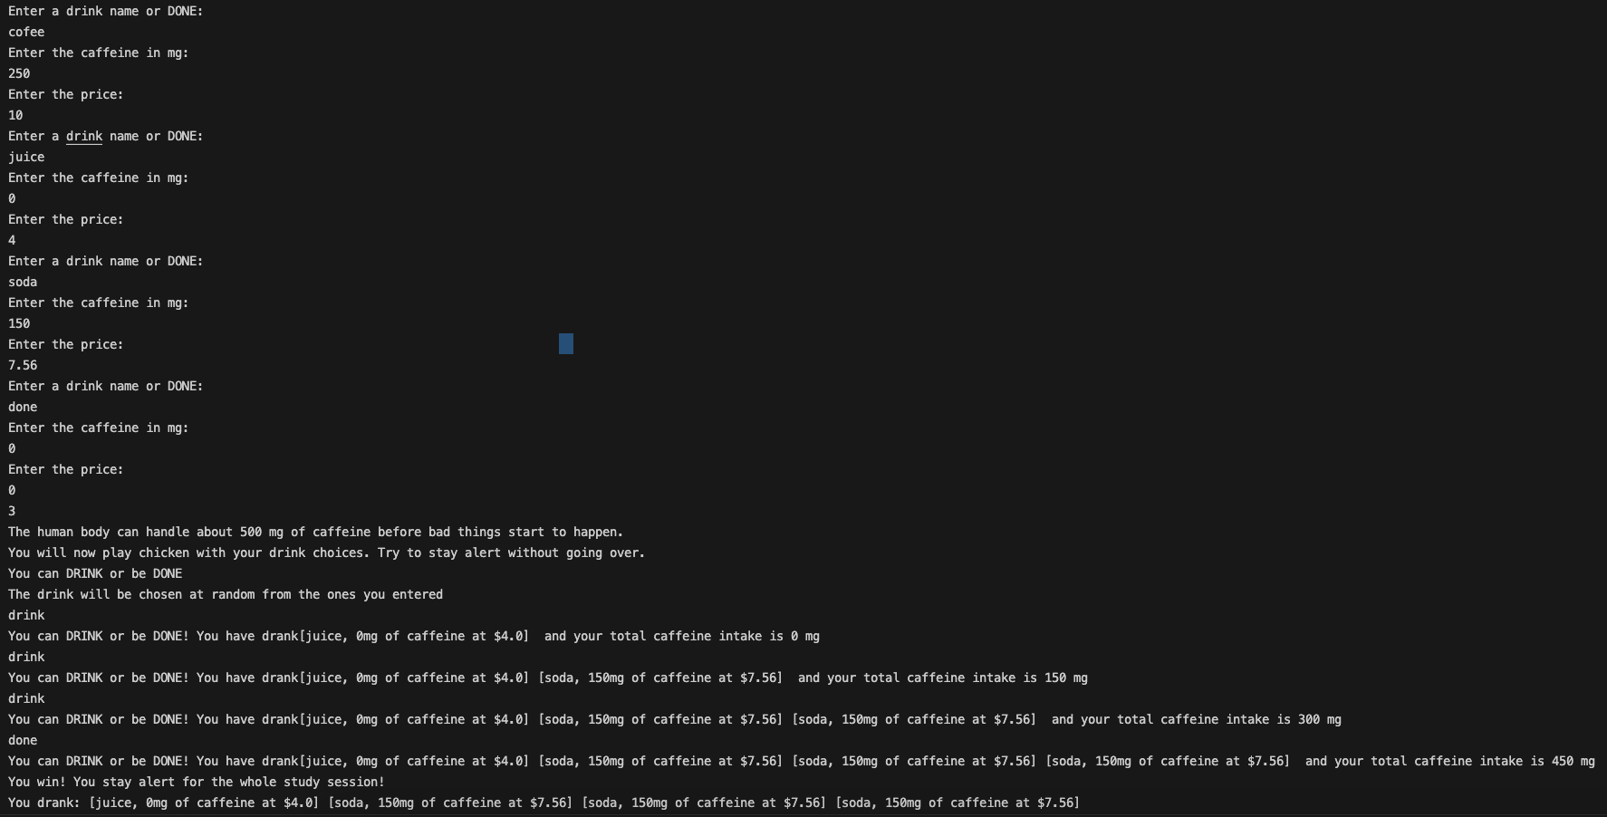

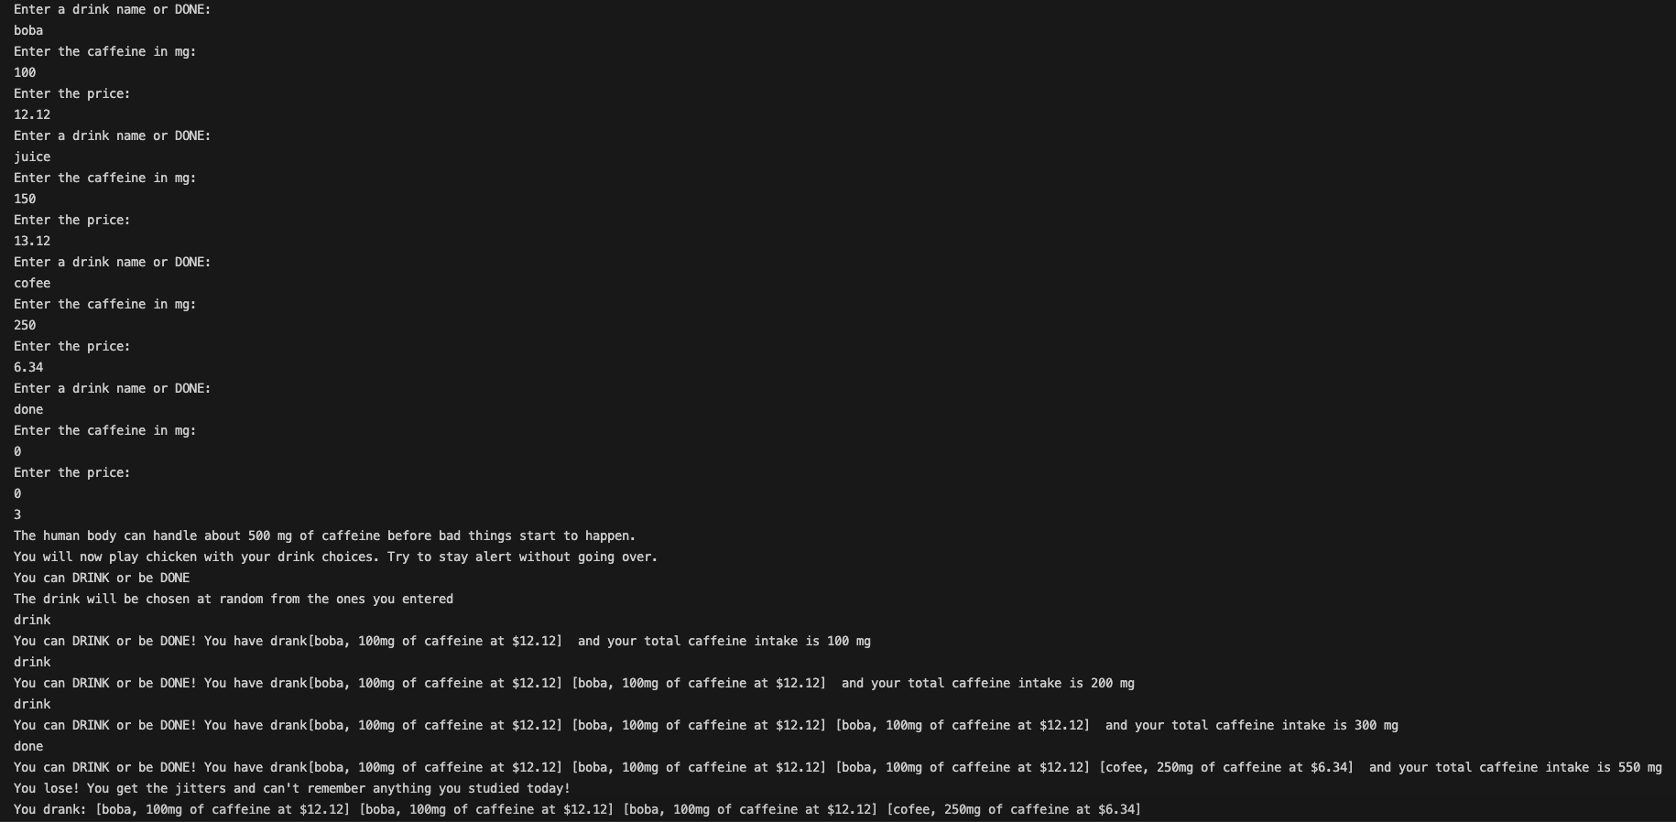

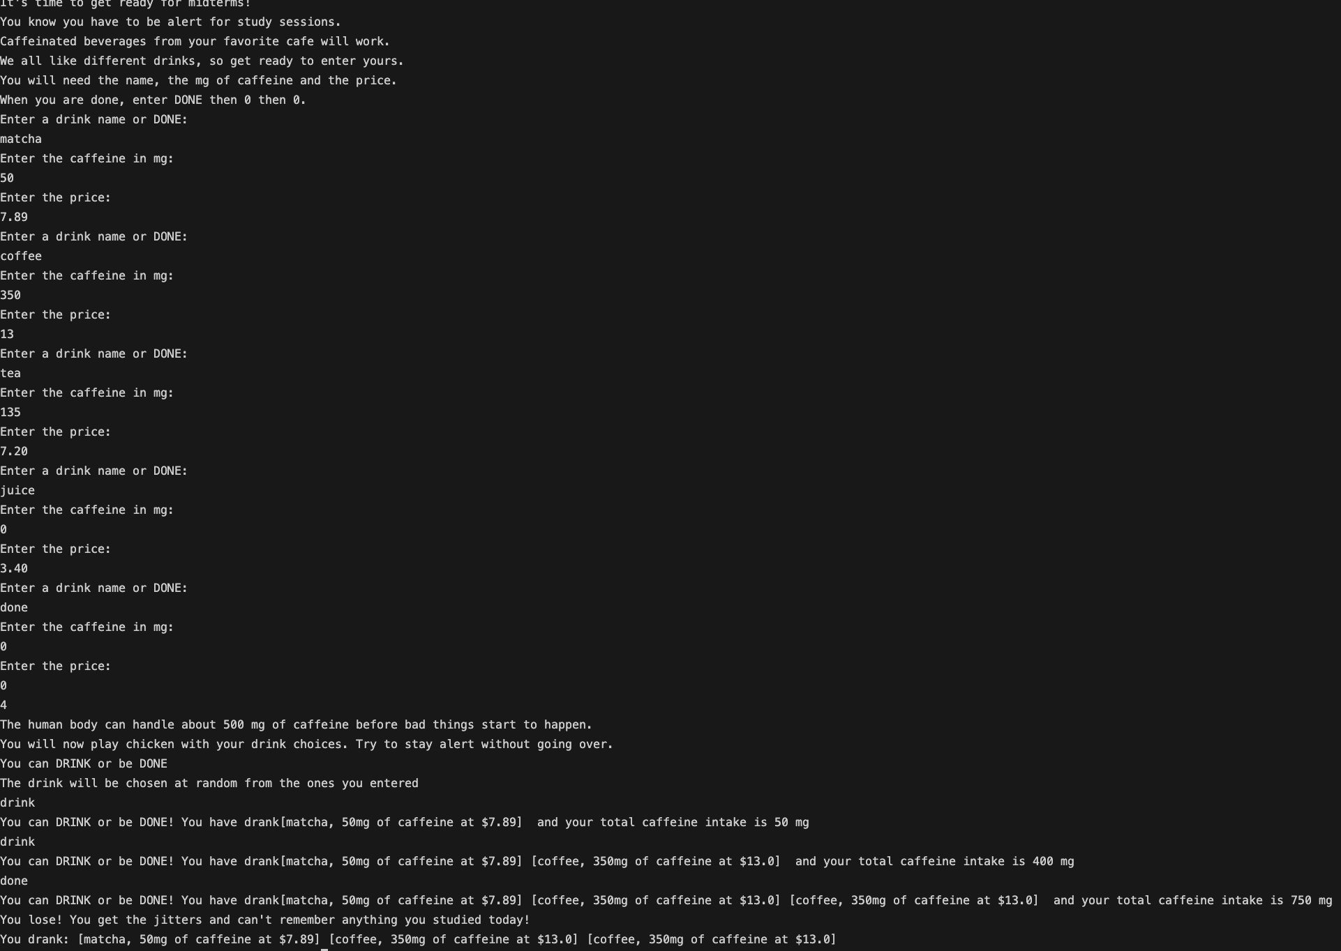

Reflect on your problem-solving:

How confident are you in the solution?

Pretty confident.

How ready do you feel for the midterm?  
  
I would say I am prepared for the most part. Probably would need to practice classes and recursion.

How comfortable are you with Project #1?

Project 1, I would say is generally doable. The only info I would need to know is the proper Unicode ranges and how to do a regex match in Java.

Reflect on your learning and your needs. After this class meeting, what topics do you feel like you learned and what topics do you feel like you need more information on to learn?

I learned about the ArrayList, the for loop, the while loop, and the enhanced for loop. I may need more info on recursion, but this is something I should just practice more.